



**SM6P07NI Digital Media Project**

**20% Research and Proposal**

**2021-22 Winter**

**Student Name: Arbindra Adhikari**

**London Met ID: 20049278**

**College ID: NP01MM4S210086**

**External Supervisor: Sandip Lamichhane**

**Internal Supervisor: Vijay Amrit Chaudhary**

**Assignment Due Date: 28th Dec 2022**

**Assignment Submission Date: 28th Dec 2022**

**Word Count: 3127**

*I confirm that I understand my coursework needs to be submitted online via Google Classroom under the relevant module page before the deadline in order for my assignment to be accepted and marked. I am fully aware that late submissions will be treated as non-submission and a mark of zero will be awarded.*

**Abstract**

This project is mainly about creating a proper documentation where it complies all the necessary elements which are related to TVC Advertisement making and all the necessary aspect by which a successful Musical TVC can be made. This documentation includes all the necessary research done in the field of this project and proposal of the project. This particular documentation can be divided into two parts. talking about the first part of the project it includes all the aspects related to the Client research. It includes the topics like literature review, product review, Client research and many more. This particular section also includes all the elements which are necessary for the proper branding propose. Talking about the second part of this project documentation it talks about the titles like the topic or the title of the project, treatment and also contribution of others. This part also talks about the testing process in which the proper knowledge about this project has been made and initial survey till gives the room for improvement.

**Table of Contents**

Section A: Research 5

1) Introduction: 5

2) Client research 11

3) Literature Review 15

4) Product Review 19

5) Summary and Conclusions 22

Section B: Project Proposal 23

1) Project Title 23

2) Research Question 23

3) Treatment 23

4) Resources 24

**4.1) Software** 24

4.2) Equipment’s 24

4.3) Distribution 25

4.4) Hardware 26

4.5) Time 26

5) Contribution of Others 27

6) Evaluation & Testing 28

References 29

Appendix 30

Methodology: 31

Table of figures

Figure 1: World first commercial,1941 6

Figure 2: Colgate comedy hour, 1952 6

Figure 3: Mr. Potato head, 1952 7

Figure 4: Shen Gui, 1979 7

Figure 5: Hey Kid, Catch! 1979 8

Figure 6: Tnuva Milk,1997 8

Figure 7: Macintosh computer commercial, 1984 9

Figure 8: Dove commercial, 2006 9

Figure 9: LinkedIn first commercial, 2016 10

Figure 10: Hulu commercial plan 10

Figure 11: Commercial decline 11

Figure 12: Sillauto cottage environment 11

Figure 13: Sillauto and Theki 12

Figure 14: Inside of sillauto 12

Figure 15: Sillauto cottage menu 13

Figure 16: Sillauto cottage food items 14

Figure 17: 1960's Commercial 15

Figure 18: Revolutionary ads 16

Figure 19: Old Spice commercial 17

Figure 20: Nike, just do it 17

Figure 21: Chevrolet: Transformers 17

Figure 22: Food advertisement reference 19

Figure 23: Restaurant advertisement reference 20

Figure 24: Music inspirations 21

Figure 25: Inspiring Music playlist 22

Figure 26: All used Equipment’s 25

Figure 27:My project Gantt Chart 26

Figure 28: Permission seeking letter 30

Figure 29: My road map 31

# 

# Section A: Research

## 1) Introduction:

**🡪**  Video production is the process of making video content for videos. It's the same as making a movie, but instead of utilizing film material, video is captured as digital signals on analog tapes or as computer data on optical discs, hard drives, SSDs, magnetic tape, or memory cards.

A proper plan is required for the project to be successful. Without a strategy, the video may not be successful. Without a proper script, shot planning, and a storyboard, one cannot imagine generating a wonderful video. which stands out to the mass, therefore for the project's success, the works are required to be split into three phases, which are as follows -:

Three stages of video production are pre-production, production (sometimes known as principal photography), and post-production.

**🡪 Pre-Production phase**

Before filming begins, all of the planning aspects of the video production process are included in pre-production. This includes tasks related to scheduling, logistics, scriptwriting, and administration.

* **Production phase**

Production is the phase that comes before and after post-production. It is where raw elements are recorded and footage is taken for the video. It includes all of the work such as shooting, working with the director, camera crew, and other crew members to block out actor movements and lighting set ups for a scene.

* **Post-Production phase**

It is the stage after production, which encompasses all stages of production that occur after shooting or recording individual show segments. When the raw footage is collected and processed, the editing of the visual and audio materials begins, the phase generally involves of content editing, sound editing and music addition, visual effects addition, color correction etc.

**The first ever TV Commercial**

At the height of the second world war, the initial television advertisement debuted. A portion of these promotions were entertaining, others were inspiring, and a couple were down changing oner the long run. They became a phenomenon in popular culture over time.

The world’s first television commercial aired for the Bulova Watch Company. The ad was only 10 seconds long, cost between $4 and $9 to create and was seen by 4,000 people in New York.

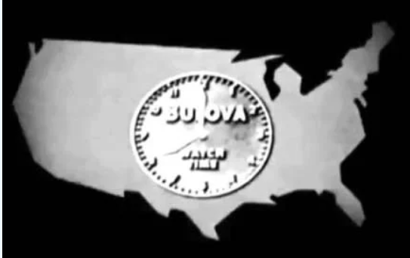

Figure 1: World first commercial,1941

**History of commercial**

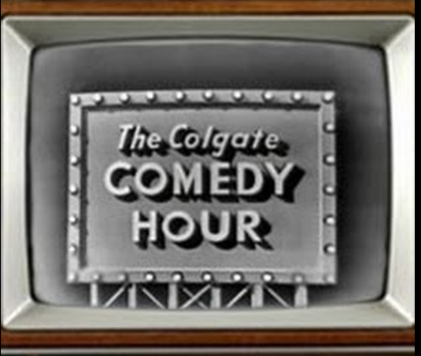

Sponsored programs were popular with big companies like Coca-Cola, Mattel, and Colgate. During the shows, these brands were talked about, and sometimes they were even incorporated into the show's name, like The Colgate Comedy Hour.

Figure 2: Colgate comedy hour, 1952

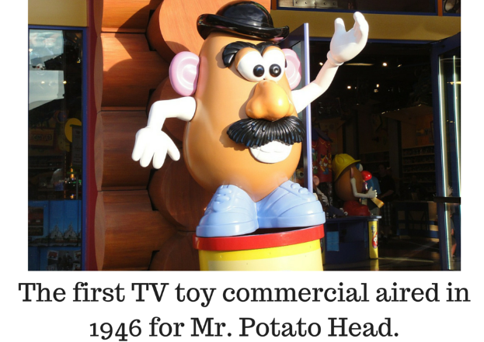

Figure 3: Mr. Potato head, 1952

The first toy to be featured in a TV commercial was Mr. Potato Head. This vintage Tv commercial for Mr. Potato Head is the first toy advertisement aimed at kids, and is just as creepy and weird as you’d imagine. In the first year alone, nearly 2 million Mr. Potato Heads were sold.



Figure 4: Shen Gui, 1979

China’s first tv commercial appeared on January 28,1979. This first commercial was broadcast on shanghai Television and ran for 90 seconds. The advertisement was for a product called ginseng tonic wine.

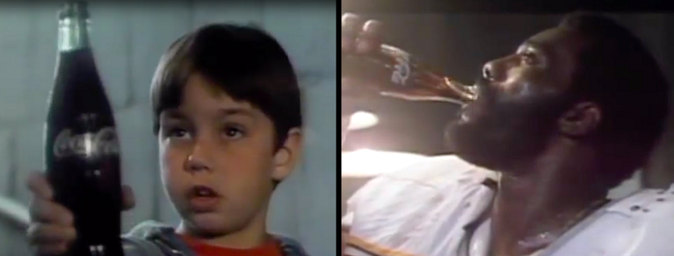

Figure 5: Hey Kid, Catch! 1979

"Hello, kid, catch!" is a Coca-Cola commercial starring "Mean" Joe Greene, a defensive tackle for the Pittsburgh Steelers. The advertisement first aired on October 1, 1979, and it was rebroadcast several times, most recently during Super Bowl XIV in 1980. One of the best television commercials of 1979, the 60-second spot won a Clio Award.

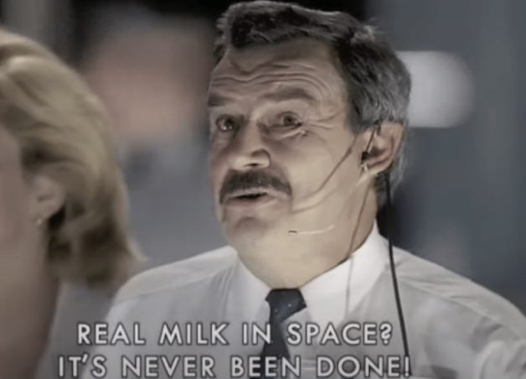

Figure *6*: Tnuva Milk,1997

On August 22, 1997, a commercial for Tnuva Milk featured cosmonaut Vasily Tsibliyev sipping milk aboard the Russian Mir space station. Alexander Lazutkin, a former flight engineer, used a camcorder to record crew commander Tsibliyev while being instructed by the commercial's director. This was the first-time milk in liquid form had been sent into space. The ad made it into the Guinness Book of World Records.

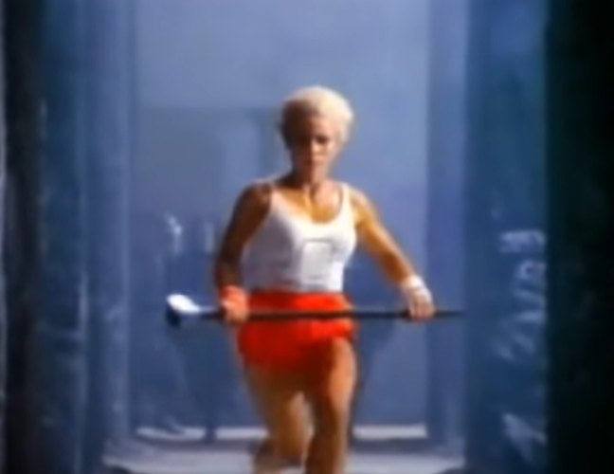

Figure 7: Macintosh computer commercial, 1984

The Apple Macintosh personal computer was introduced in the American television commercial "1984" It was brought about by Steve Hayden, Brent Thomas and Lee Clow at Chiat/Day, created by New York creation organization Fairbanks Movies, and coordinated by Ridley Scott. Three months after the advertisement aired, the company sold $155 million worth of Macintosh computers.



Figure 8: Dove commercial, 2006

Unilever launched the Evolution advertising campaign, also known as The Evolution of Beauty, in 2006 as part of its Dove Campaign for Real Beauty to promote the newly established Dove Self-Esteem Fund. To become a model for the advertisement, a woman underwent a lengthy process of hair, makeup, and Photoshop.

On May 5, 2003, LinkedIn made its debut. With its mission to "create economic opportunity for every member of the global workforce," the platform for professional networking LinkedIn brought some of their most memorable businesses. The idea for the advertisement, which ran during the 88th Academy Awards, was NASA's decision to use the networking platform to find new astronauts.

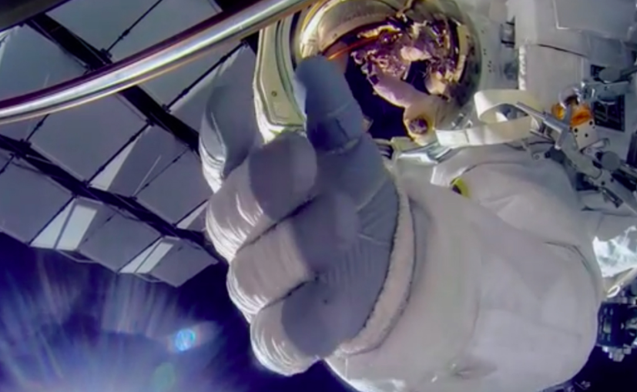

Figure 9: LinkedIn first commercial, 2016



The way we watch advertising has changed thanks to Hulu. Depending on how many ads they want to see, viewers can select a package deal, some of which are even exclusive to the streaming service.

Figure 10: Hulu commercial plan

44% of responders said that streaming services like Netflix and Hulu have reduced their use of live TV. People don’t want to be disturbed by commercials leading to a decline in commercial ads.

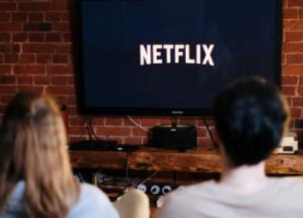

Figure 11: Commercial decline

## 2) Client research

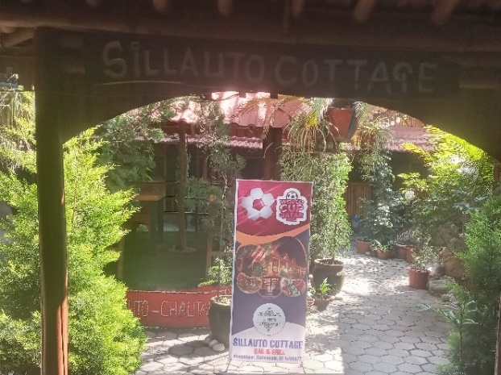The clients are the folks from the silauto cottage located in annamnagar kathmandu, they have been running the cottage for more than 3 years and are kind and really helpful. They work really hard to ensure that the cottage deliveres their best make the customer feel the cottage like it’s their home they have various nepali cuisine as well as delicious fast food items not only that but many tradition nepali items like sillauto,theki,laltin nanglo as well. The environment inside the cottage is really great filled with nature and fresh set of air.

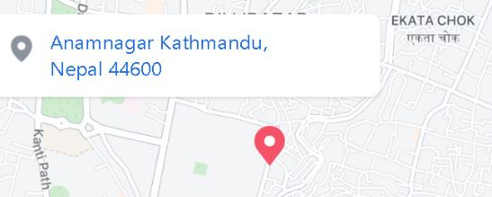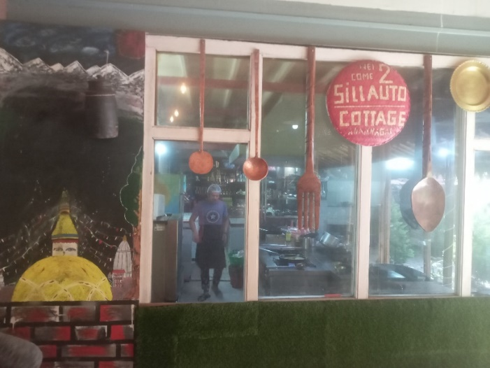

Figure 12: Sillauto cottage environment

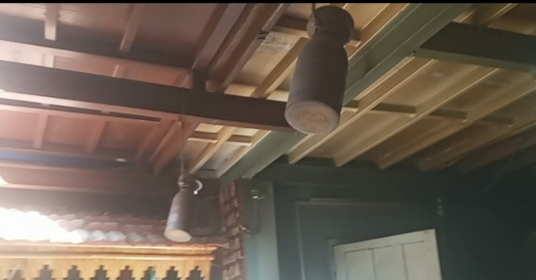

Figure 13: Sillauto and Theki

There is a big sillauto inside where they grind the spices and many more traditional Nepali items. The cottage is having a very good environment and great ambiance as well as great customer services for the audience, not only you can enjoy peaceful sound of the waterfall you can enjoy your delicious foods items with family and friends.

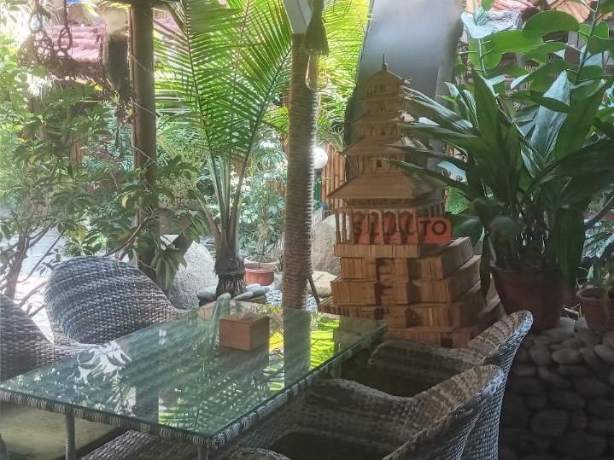****

Figure 14: Inside of sillauto

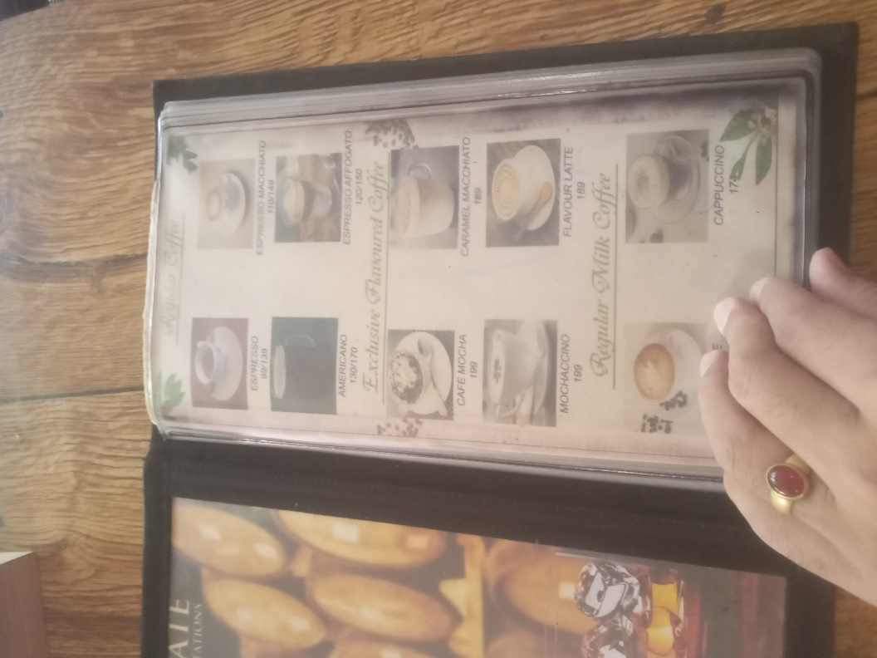



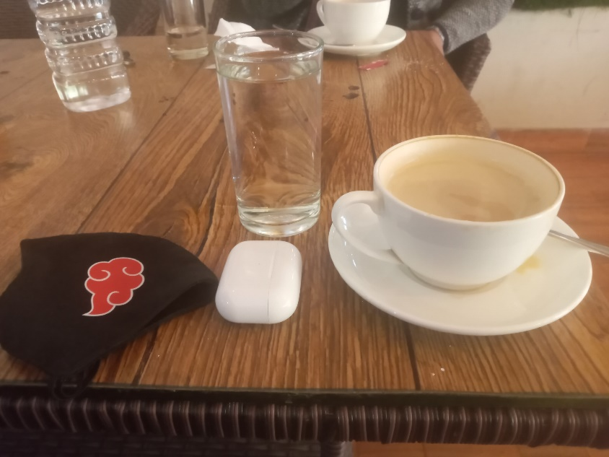

Figure 15: Sillauto cottage menu

The menu for the cottage bar and grill, you can enjoy all your Nepalis cuisine, morning to dinner worth of foods with the facility of home delivery at any time.

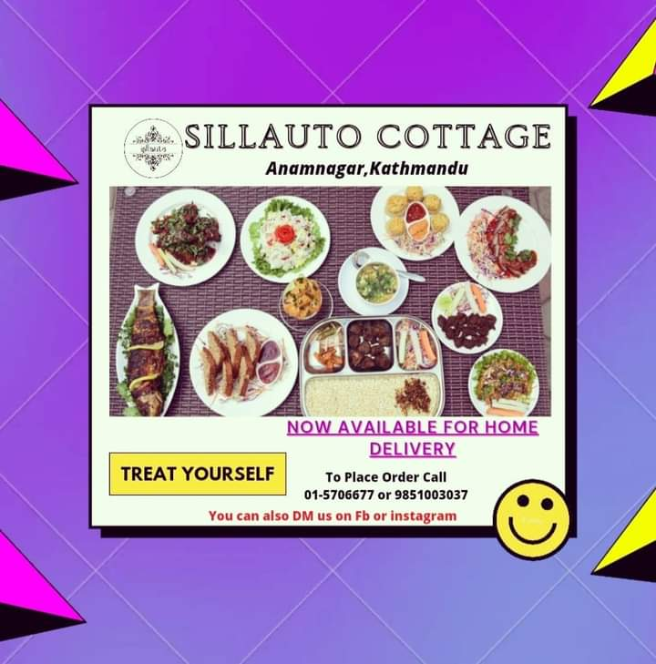



Figure 16: Sillauto cottage food items

There are many varieties of foods items at the cottage like more of your traditional Nepali food items and typical Nepali cuisine on the board.

## 3) Literature Review

For my project I am planning on doing a video production i.e., shooting a TVC commercial with my original music which will be a real client-based project, I will be combining all my knowledge on music and video shooting with some 2d if possible, while shooting for the video definitely there will be lots of issues to digest like less people to shoot, actor and drone shot, to solve and overcome them I have asked some help from staffs and some friends for the drones and the customers for some acting if possible.



**What were TV Commercial like in the 1960’s?**

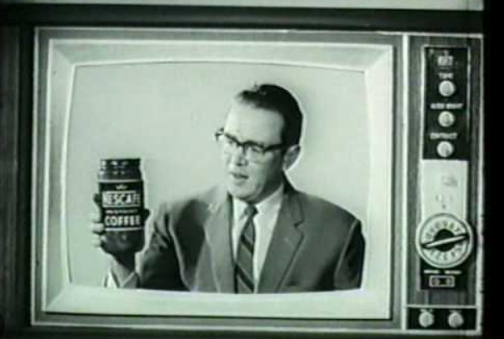

More than one commercial could air on a single show by the 1960s. As a result, more businesses were able to benefit from this marketing strategy. Additionally, since television was now available in color, the possibilities were endless.

Figure 17: 1960's Commercial

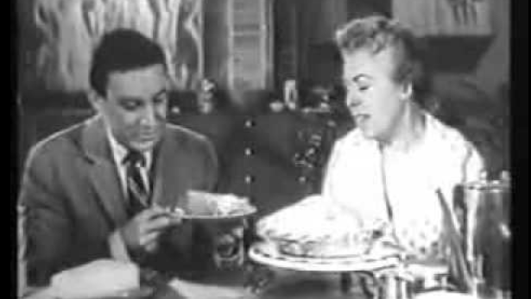

Figure 18: Revolutionary ads

You have to look at sponsored programs in the past to see how revolutionary commercials were in the 1960s. The advertiser had complete control. They had complete creative control over the content because they were paying for the advertisements that ran during the shows.

**What makes a great television advertisement**

**🡪**Each day, the average person watches about four hours of television. This gives advertisers a lot of chances to get their message in front of people who might buy from them. The impact on popular culture is what makes television advertising truly valuable. The most memorable TV commercials present a story, appeal to our emotions, or include a catchy tune or humorous event. It really is the advertiser's responsibility to make sure that kind of commercial is being produced.

Traditional Commercial

Some examples of traditional commercial can be old spice: The Man your Man Could Smell Like, Nike: Just Do It, Chevrolet: Transformers etc.

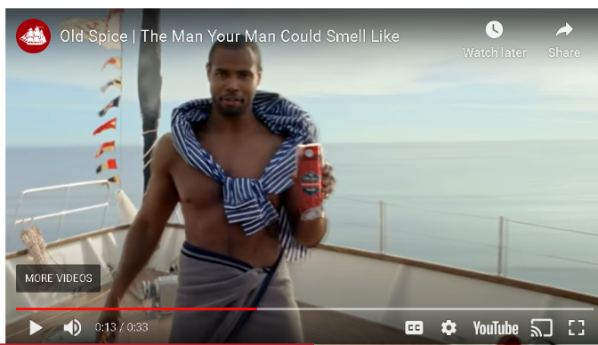

Old Spice is a well-known male grooming brand with comedic advertisements. The company has produced a number of memorable TV ads, including “The Man Your Man Could Smell Like.”

Figure 19: Old Spice commercial

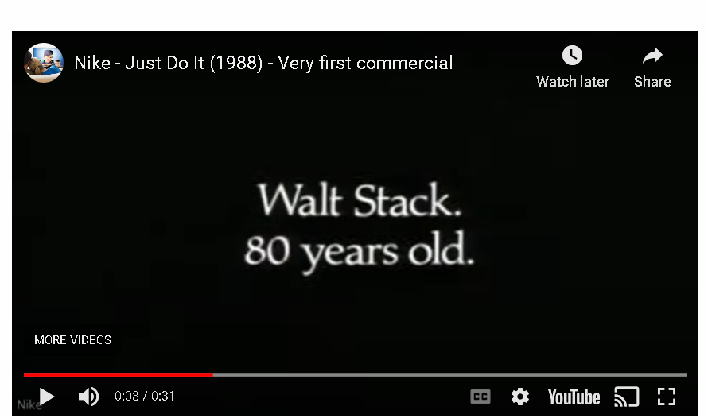

Nike is a well-known manufacturer of sportswear and inspirational advertisements. The slogan "Just Do It" was used in a commercial featuring an 80-year-old man.

Figure 20: Nike, just do it

Chevrolet was one of the brands featured in the Transformers movies, which are known for their product placement. The vehicles of the company were shown a lot in the movies, and they even made a few appearances that had to do with the plot.

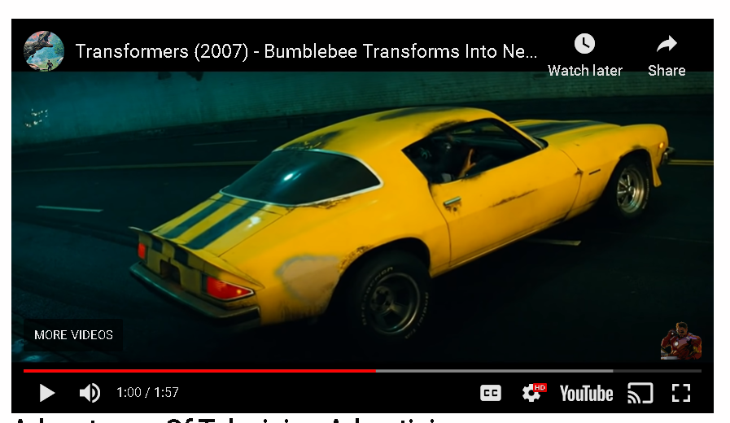

Figure 21: Chevrolet: Transformers

**Television Advertising**

Advantages

**1) Attention-Grabbing**

TV commercials aim to pique the audience's interest and keep it for the duration of the commercial. This is done with creative graphics, music, and special effects.

**2) Creates An Emotional Connection**

Ads on television frequently use emotions to convey their message. This can be accomplished with music, pictures, or even stories.

**3) Appeal To Everyone**

Television is one such advertising medium that does not require its audience to be literate. It is suitable for readers of all ages and reading levels.

**4) Trustworthy**

Television advertising is thought to be more trustworthy than other forms of marketing, such as online advertisements. This is done so that TV commercials can take advantage of viewers’ trust in the channel.

Disadvantages

**1) Not interactive**

Television is not very interactive because it is a one-way medium. It might be hard to keep the audience interested and get them to behave in a certain way.

**2) Less flexible**

Editing a TV commercial is both expensive and time-consuming after it has been made. This suggests that advertisers must be confident in their advertising copy before it airs.

**3) Expensive**

Television advertising is one of the priciest forms of marketing. This is done so that a television commercial of high quality can be made, produced, and broadcast.

**4) Repetition to be effective**

Advertising on television is useless unless it is shown repeatedly. This can be costly and time-consuming for advertisers.

I will study such information on tv advertising to know the audients more and know exactly what they are looking for a tv commercial and try to do my best on the project.

**Future of tv commercial**

In this digital world, most of us are quick to pay extra or hit "skip this ad" whenever possible. This has been the downfall of the TV commercial, and it's hard to say where we go from here. We can’t deny the fact that if commercials can be done properly, it can be thought provoking, hilarious, heartwarming and provocative. Although streaming is ad-free these days, the future of television advertising may still hold a few surprises.

## 4) Product Review

I’m trying to promote the hotel experience encouraging people through the advertisement and convey a message to the public in a fun way through the means of motion graphics and music.

The project has some inspiration from some emotional food advertisement as well as many hotel/ foods houses advertisement. Some of the video I watched and took some ideas.

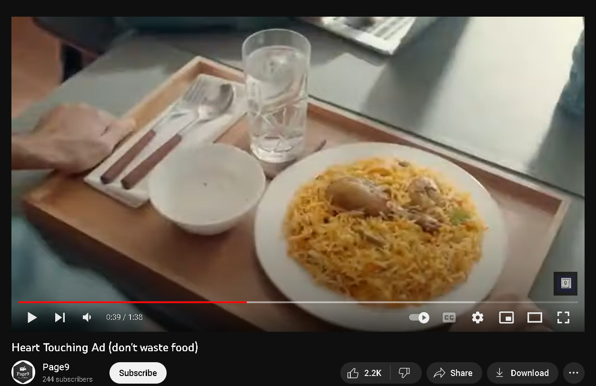

Figure 22: Food advertisement reference

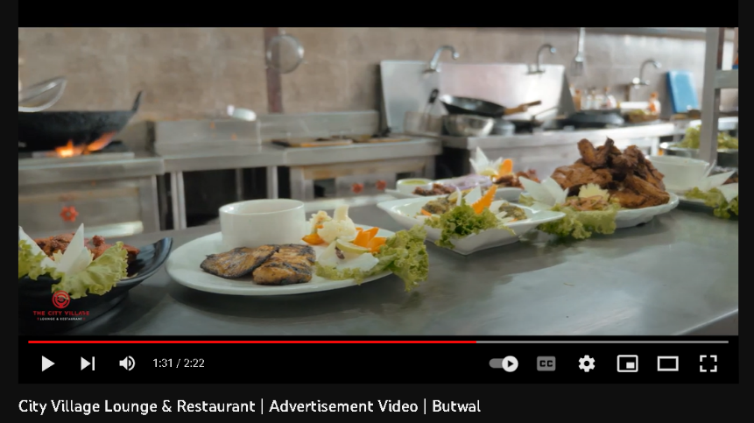

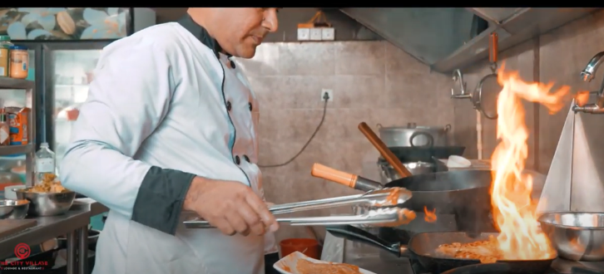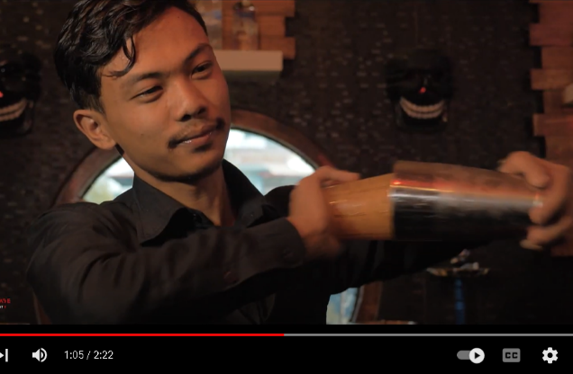

Figure 23: Restaurant advertisement reference

Similarly like in the videos above I will be having some emotional moments related to food also as in the 2nd video I will be showing various food items inside the food cottage, the cinematics environment inside the place and the staff working in the kitchen the ambience and customer service will also be shown through the video. I will be creating some great beats and music for the video there will be slight music on the background later in the video, the music will change be according to the feeling of the character in the video.

The music will change according to the feel of the character, so that the viewer watching the video can also relate and feel the same.

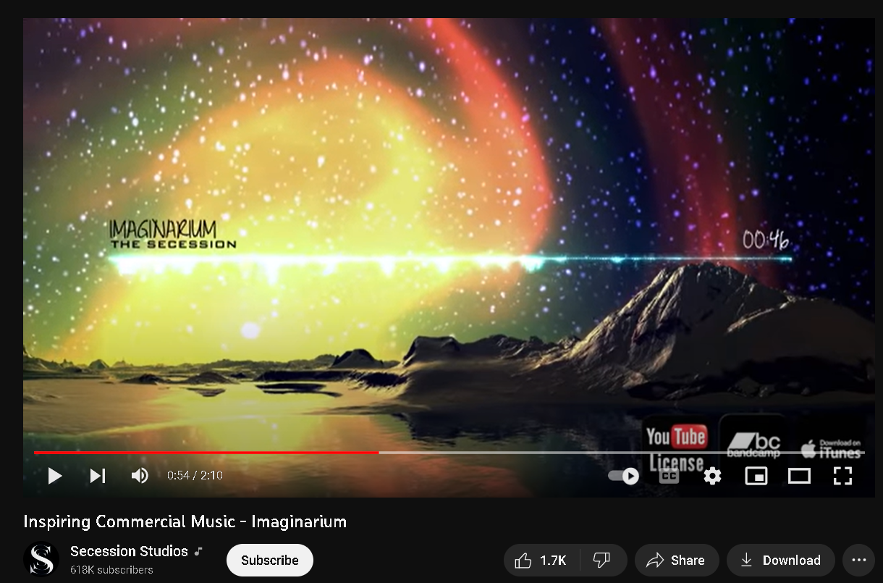

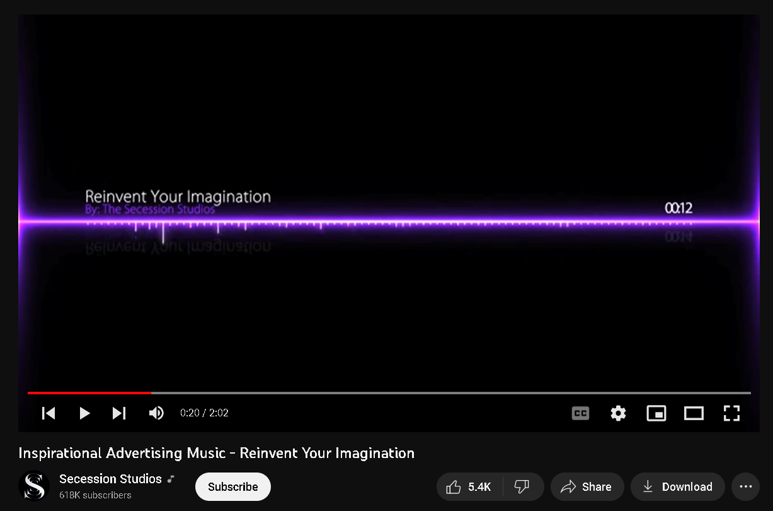

Figure 24: Music inspirations

I looked up for some commercial music to make and took some inspiration in YouTube and I came across the above music’s which were really my inspiring. The above video is some music which I can really see fit in the advertisement the playlist has many varieties of song be it encouraging emotional and happy, these tracks has some great selection for the project.

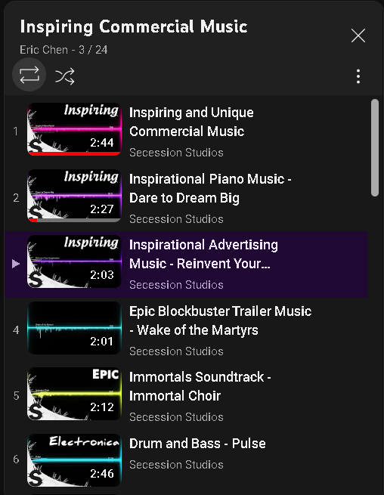

Figure 25: Inspiring Music playlist

## 

## 5) Summary and Conclusions

This coursework has enlightened me about client-based work on tv advertise making and camera angle for shooting, which was very helpful and, it has taught me the importance of planning and management of crew, budget, cinematics and, more about, the history of television commercial Thank you, sir/Madame,’ for your support and guidance.

Overall, the video should show a proper promotional TVs advertisement which can give a proper message as well as satisfy the viewer and hence attract the people to actually go to the place.

**Section B: Project Proposal**

# 1) Project Title

**A Sillauto cottage experience**

In the video I will show a guy really starving and ready to pass out I want to capture the feeling of hunger during which there will be display of sad music, the music will transition in the video according to the character feelings, he comes across a road he sees the sillauto cottage nearby, the energy from inside drags him like a drug. He goes inside the cottage looking sad, hungry and innocent, the inside of the cottage makes him a completely different person, by the time he enters outside he will be full of energy and ready to take on life.

Objectives

To promote the place and inspire the people to come in the cottage.

To connect with the viewer and give an emotional connection on foods and culture through music.

## 2) Research Question

**How can I make the video more eye catching to promote a place through commercial/ advertisement and catch the heart of many?**

🡪 As we all know advertisement has a great impact on the viewer as it is a decider factor for people to buy the products. It can be inspiring, emotional and life changing which depends on the director’s vision while making the commercial, not only can it help to promote certain product it can also help promote restaurants, institutions, hotel and many more.

To make the commercial more captivating it needs infographics and images to make it more engaging, as they can help to convey a message in a way that is both quick and effective, we know images are excellent at attracting attention they can also be very persuasive, so making the right choice is very important.

To catch the heart of the viewer I need to take advantage of the first few second of the video as the beginning is crucial part, then need to highlight the great things about the brand or company and what draws viewers’ attention to the brand and at last need to successfully explain the watchers why…?

## 3) Treatment

Talking about the perspective of the audience after watching this short commercial it is going to be very emotional and very loveable. This television commercial will give the viewer an experience of a food hut, Audience will connect to this TVC as there will be a emotional message at the end showing love for foods and your country, this advertisement will also show variety of traditional Nepal food to promote our culture. The audience can feel the patriotism and love for one’s country they will also get the idea as the story line is hitting the mind of the audience. The message which the story from the TVs is trying to give is that restaurants experiences can be more fun than they imagined they are not expensive and waste of their money, The commercial will always be remembered in the mind of the audience as there is emotional connection of the country and its food.

## 4) Resources

### **4.1) Software**

Adobe software’s will be used to create motion graphics and editing the raw footage



 Da Vinci for color grading

 FL studio/reason will be used to create sounds and beats according to the mood of the scenes in the video

### 

### 4.2) Equipment’s

* The following are the resources required to shoot and complete the project.

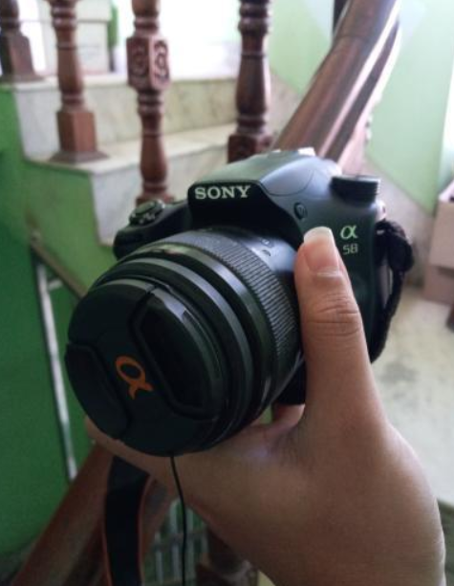



**Lighting equipment’s**

**Sony DSLR**

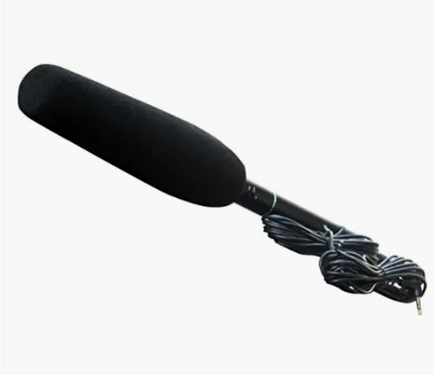

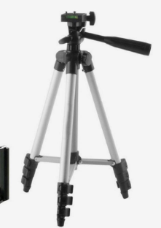

Microphone

🡪 Panasonic Super Uni-directional electret condenser microphone

**Tripod 🡪** Weifeng Wf6663A

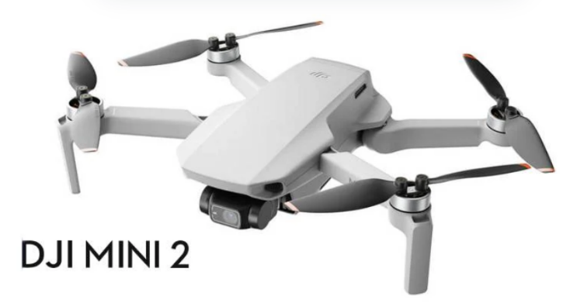

Figure 26: All used Equipment’s

### 

### 4.3) Distribution

**Social Media: - Facebook, Instagram, TikTok**

**Video: - YouTube, TikTok**

### 

### 4.4) Hardware

RAM: 16 GB

Processor: Intel(R) Core (TM) i7-1065G7

GPU: Nvidia GeForce MX230

System-type: 64-bit operating system,

Operating system: Windows 11

### 

### 4.5) Time

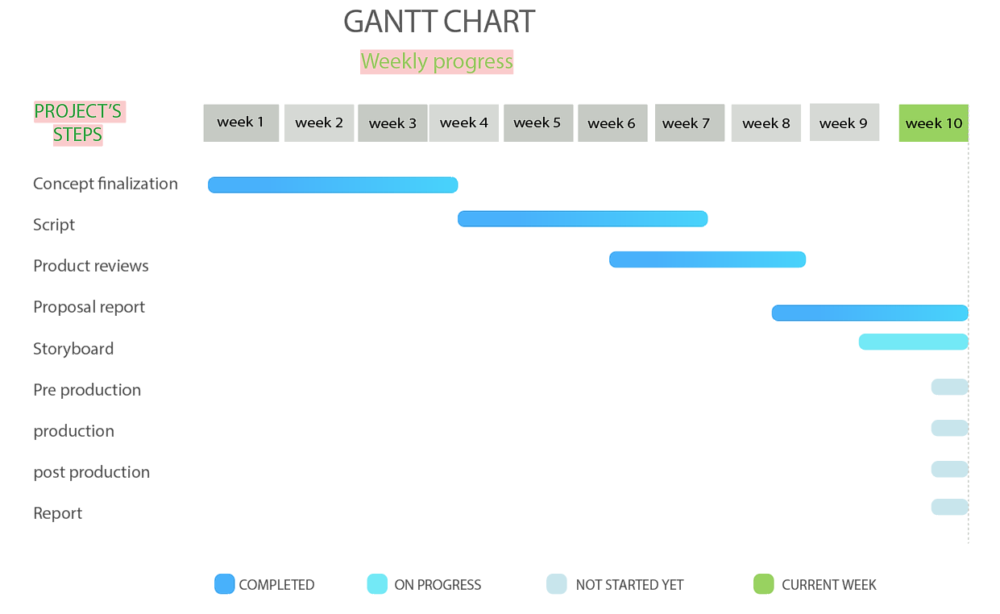

**Figure 27:Gantt Chart week 1 - week 10**

## 5) Contribution of Others



The project was only possible because of the people who had given me permission to shoot, the humbleness, their kindness and helping nature was also great contribution.

**The Staffs**



The staff were very supportive and respectful, they are going to be a huge help for serving the food item and helping in the video.

**Mom**

She introduced the place and I was really satisfied, she has a big contribution for helping, Fist time going I thought it will be small place but turned was it wasn’t what it seems, it was great inside and after seeing the traditional food items, the environment inside and staffs I was ready to see how I can make a great TVC video out of it.

**Friends**

I have asked friends to borrow drones and have seek some ideas on the camera angles and some help for the shoot, like managing lighting and discussion on how to make it better with them.

## 6) Evaluation & Testing

Evaluation is a very importance process as evaluation paves the way to project improvements.

By displaying it to my coworkers and friends, I will assess my progress. Additionally, I will evaluate my project based on my weekly progress. Since this is a project that will last a year, I want to get as much advice and feedback as I can from everyone I know, including my supervisors and colleagues.

After completing my project, I will be first testing the game myself and pass it on to my supervisors, friends and family to get feedback.



# 

# References

9, P., Oct 13, 2019. [Online]   
Available at: https://www.youtube.com/watch?v=qOQtQFh6WFs  
[Accessed 23 December 2022].

Anon., May 15, 2019. [Online]   
Available at: https://www.youtube.com/watch?v=qOQtQFh6WFs  
[Accessed 23 December 2022].

Anon., Nov 6, 2011. [Online]   
Available at: https://www.youtube.com/watch?v=rg6_e9eMp-s&list=PLNpruo3rG6fm_3C3RqEwr5hH7jogoZ7yb&index=4  
[Accessed 23 December 2022].

Mertes, A., May 06th, 2021. [Online]   
Available at: https://www.qualitylogoproducts.com/promo-university/history-of-tv-ads.htm  
[Accessed 2022].

Mertes, A., May 06th, 2021. *History of tv ads.* [Online]   
Available at: https://www.qualitylogoproducts.com/promo-university/history-of-tv-ads.htm  
[Accessed 20 December 2022].

Pahwa, A., May 7, 2022. [Online]   
Available at: https://www.feedough.com/television-advertising-definition-types-examples/  
[Accessed 20 December 2022].

**Future references**

LANNOM, S., JUNE 28, 2020. *DIRECTING.* [Online]   
Available at: https://www.studiobinder.com/blog/types-of-camera-shot-angles-in-film/  
[Accessed 25 December 2022].

McIntire, J., n.d. *Digital photography school.* [Online]   
Available at: https://digital-photography-school.com/studio-lighting-equipment-guide/  
[Accessed 25 December 2022].

# Appendix

**Legal and Ethical Considerations**

Before beginning the project, legal and ethical considerations must be made.I would ensure that I have a valid letter before obtaining approvals and authorization. I will only shoot after obtaining permission from the owner to utilize various elements in the video.

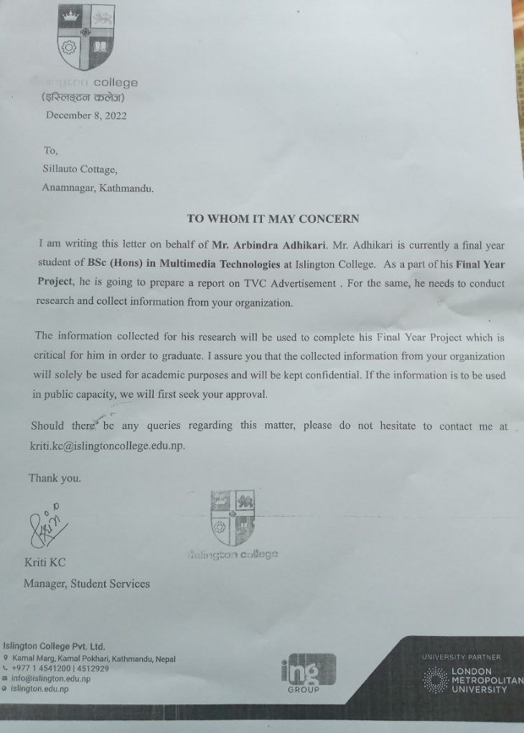

Figure 28: Permission seeking letter

# Methodology:

A methodology for project management is a set of principles and practices that help you organize your projects to get the most out of them.

Wrote script and shared with supervisor

Looked for inspiration on websites YouTube

Finishes my proposal and was clearer on my work.



Discussions with both supervisors

Found more videos on YouTube/website for even more idea.

Finalized my concept and ideas

Figure 29: My road map